CSCI 306 Final Assignment - Gateway
200 Points

BE SURE TO READ THE INSTRUCTIONS BEFORE YOU BEGIN! These questions will not make sense unless you have read that document, as it contains additional requirements. Your answers should be all in a single document, either rtf, pdf or docx. Text for assignment must be in text readable format (i.e. do not submit text as graphics).

General points for design, clarity, completeness, grammar, spelling, English, etc. – 20 pts

1. Provide a brief explanation of the system you are modeling and its components. What are the main elements of the architecture and how do they work together? (20pts)

The system I am modeling is the power distribution system. This system is crucial for the operation of all other systems on board the station, as they rely on a consistent and reliable supply of electricity. If the power distribution system were to fail, it would lead to a cascading failure of all other systems, jeopardizing the safety and functionality of the entire station. Therefore, the power distribution system is designed with fail-safes to ensure that critical systems remain operational even in the event of partial failures. The architecture of the power distribution system consists of several key components that work together to manage the flow of electricity throughout the station: power sources, distribution units, control system, monitoring, diagnostics, and fail-safe mechanisms.

2. Insert your UML diagram of your design below. Be sure that the diagram is readable! Break it up into a couple of pieces if needed. Because this is take-home, links and format of UML need to be correct. The following answers need to be consistent with the UML design. (40pts)

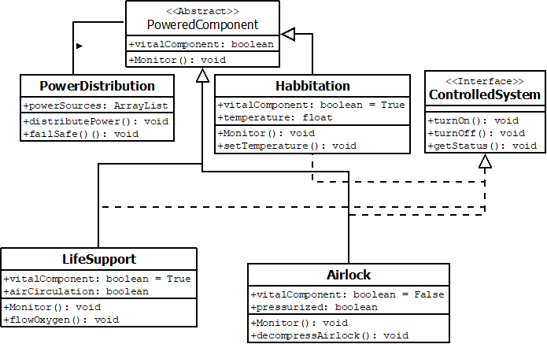
3. What are your abstract class(es)? Choose one and explain why your abstract class should be abstract, and why you need child classes. (20pts)

The abstract class I have chosen is called PoweredComponent. This class is abstract because it represents a generic powered component. It shows the common functionality and attributes shared among different types of powered components, such as LifeSupport, Airlocks, and Habitation. The reason PoweredComponent should be abstract is that it serves as a blueprint for specific types of powered components but does not represent a concrete implementation on its own. Instead, it defines abstract methods and properties that must be implemented by its subclasses. For example, all powered components may need to be monitored for performance and have diagnostics capabilities, but the specific implementation of how monitoring and diagnostics are carried out will vary depending on the type of component.

4. What are your interface(s)? Choose one and justify why it makes sense to include that interface. Do NOT just grab a function from one of your classes and throw it into an interface. Your design and explanation should clearly show when an interface is appropriate compared to an abstract class. (20pts)

The interface I've created is called ControlledSystem. This interface is designed to be implemented by powered components that require external control. It makes sense to include this interface because not every powered component needs to be controlled externally. Some components may simply serve to accept power without any need for external intervention. By defining ControlledSystem as an interface, we allow for a clear separation of functionality: powered components that require control functionality can implement the interface, while those that do not need such functionality can omit it. The interface specifies methods for controlling the operation of the system, such as turning on/off and setting different operating modes (e.g., standby, normal, emergency).

5. Explain how your design adheres to the Open-Closed Principle (OCP). Be specific. (20pts)

The design adheres to the Open-Closed Principle by allowing for extension without modification. New functionality can be added without needing to alter existing code. For instance, if a new type of powered component needs to be integrated into the system, it can extend the existing PoweredComponent class and implement its own specific functionality without modifying any of the existing child classes or the parent class. Also, if the new component requires external control capabilities, it can simply implement the ControlledSystem interface. If I wanted to add a Weapons system, I could extend the PoweredComponent class and implement the ControlledSystem class to add this functionality.

6. Explain how your design adheres to the Interface Segregation Principle (ISP). Be specific (e.g., you might describe a naïve version of your design that would violate ISP, to show that yours does not violate ISP). (20pts)

My design adheres to the Interface Segregation Principle because components only use methods that are relevant to their functionality. If my design did not adhere to ISP, then every controlled component would have to implement functions that it doesn’t necessarily need or use.

7. Explain how someone might extend your program in a way that violates Liskov Substitution Principle (LSP). Be specific (i.e., give a concrete example). (20pts)

Someone could extend my code in a way that violates the Liskov Substitution Principle by creating a FaultyComponent subclass of the PoweredComponent which always returns incorrect data and therefore that class could not be substituted for the PoweredComponent class. This would violate the assumptions made by the other child classes. Therefore, it would not adhere to LSP since objects of a subclass should be able to be used interchangeably with the parent class.

8. Include code for one failing JUnit test method. Include a brief comment about what you are testing. Remember that TDD is a design process. This method should test some planned functionality (e.g., test that a car slows down if another car’s brake lights are showing), and NOT just a setter/getter. (20pts)

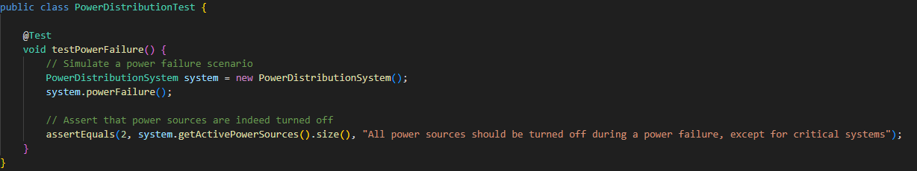

This test ensures that during a power failure critical system such as life support and habitation are still getting minimal power to operate.

